|  |
| --- |
|  |
| Advanced Development System Group Members |
| |  |  |  | | --- | --- | --- | | …. | …. | …. | |

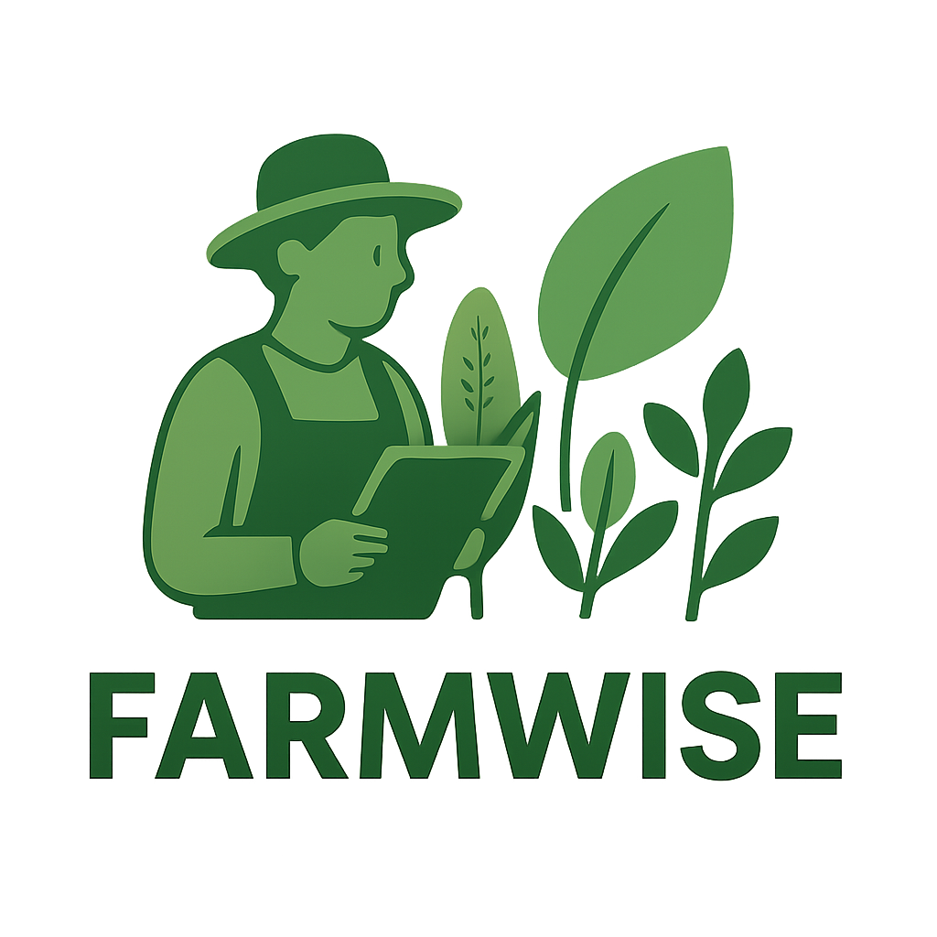

## Group Members

|  |  |
| --- | --- |
| Student Names | Student Number |
| Nkoana Hope Lerato | 202204804 |
| Mawela Mpho Precious | 202233722 |
| Khalo Ayanda Girly | 202213324 |
| Dlamini Kelebogile Sylvia | 202224253 |



## Report

## Background and Context

Agriculture plays a vital role in South Africa’s economy, contributing significantly to food security, employment, and overall economic growth (Department of Agriculture, Land Reform and Rural Development, 2022). However, the sector faces growing challenges because of climate change and global warming. Rising temperatures, irregular rainfall, prolonged droughts, and extreme weather events such as floods and frost have disrupted farming activities across the country (Scholes et al., 2015). These environmental changes directly impact crop yields, livestock production, and farmer livelihoods, with smallholder farmers being the most vulnerable due to limited access to advanced resources, technology, and financial support (World Bank, 2021).

South Africa’s vulnerability is compounded by its **semi-arid climate** and heavy reliance on rain-fed agriculture (Ziervogel et al., 2014). Provinces such as Limpopo, the Free State, and the Northern Cape frequently experience droughts and water scarcity, reducing agricultural productivity and increasing food insecurity. In rural areas, this situation is further linked to rising poverty and unemployment (Department of Environmental Affairs, 2018). Moreover, the agricultural sector often depends on traditional farming techniques, which limits farmers’ ability to adapt to sudden or extreme weather changes (Archer et al., 2018). For instance, untimely rainfall or unexpected heatwaves can result in wasted seeds, poor harvests, and economic losses.

To address these challenges, **Information and Communication Technology (ICT)** offers innovative opportunities. ICT-driven solutions such as **real-time weather monitoring, predictive analytics, mobile/web applications, and digital advisory platforms** can provide farmers with actionable insights to adapt to climate variability (FAO, 2020). By integrating tools like the **OpenWeatherMap API** for weather forecasting with modern web technologies (Django, Python, HTML, CSS, and JavaScript), farmers can access localized forecasts, crop recommendations, pest alerts, and planting schedules. These systems not only bridge the information gap but also promote **climate-smart agriculture**, helping farmers optimize their resources, increase resilience, and improve productivity (Mutua et al., 2016).

Furthermore, ICT enables **scalable and sustainable solutions** by combining **data visualization, machine learning, and service-oriented architectures (SOA)** to deliver modular and reusable services. For example, a weather service can fetch climate data, a pest module can provide alerts, and a calendar service can generate planting reminders. Together, these components can form an integrated digital platform that empowers farmers with the knowledge needed to make data-driven decisions. Such innovations are crucial for strengthening agricultural sustainability and food security in South Africa amidst the growing pressures of climate change.



## Methods

**1. Methods**

The development of the **Smart Weather Advisory System** followed a structured ICT-driven approach.

* **Data Collection:**
  + Weather data was sourced using the **OpenWeatherMap REST API**, which provides JSON-formatted real-time and forecast weather data.
  + A GET request to api.openweathermap.org/data/2.5/forecast returns 7-day hourly predictions for temperature, rainfall, and humidity.
* **System Development:**
  + **Backend:** Built with **Django (Python)** to manage user registration, authentication, and data flow between services.
  + **Frontend:** Designed with **HTML, CSS, and JavaScript** to provide an interactive, mobile-friendly interface.
  + **Visualization:** Weather and pest data analyzed and displayed using **charts**
  + **Database:** Stored farmer data, crop suggestions, and pest/disease information in a structured format for easy retrieval.
* **Collaboration and Version Control:**
  + Used **Git and GitHub** for version control, allowing for collaboration, real-time tracking of code changes, and safe backups.
* **Testing:**
  + **Unit Tests:** Checked whether the REST API returned valid data.
  + **Functional Tests:** Verified signup/login, chatbot responses, and calendar features.
  + **User Simulations:** Tested the workflow of a farmer entering a location, receiving forecasts, and selecting crops.

This structured methodology ensured that the solution remained modular, reusable, and reliable.



## Results

Charts and Visuals to Include

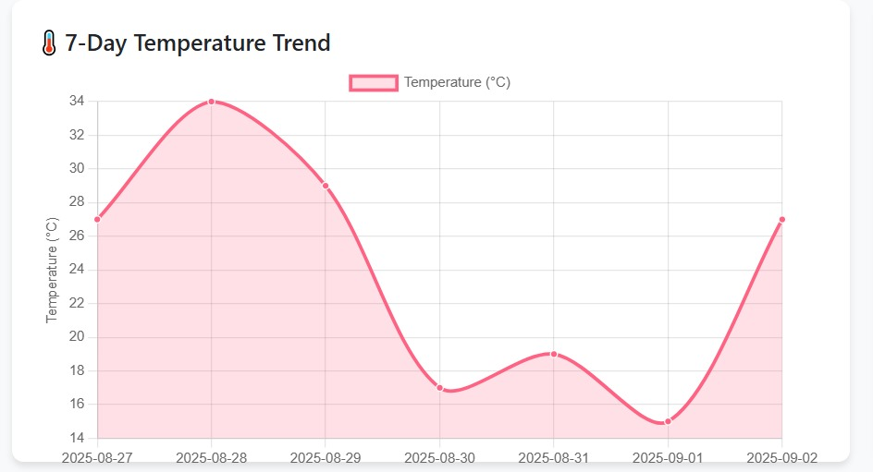

1. Temperature Trend Line Chart

Description:

This line chart visualizes the 7-day temperature pattern, providing farmers with critical insights into recent weather trends. The x-axis represents the dates, while the y-axis displays temperature values in Celsius. The smooth curve connects daily temperature points, showing the progression and variability of weather conditions over the week.

Purpose & Value:

* Frost Risk Assessment: Enables quick identification of temperature drops near or below freezing (0°C)
* Growing Condition Analysis: Helps determine optimal planting and harvesting windows based on thermal patterns
* Trend Prediction: Allows farmers to anticipate upcoming weather patterns and make proactive decisions
* Data-Driven Planning: Supports irrigation scheduling and crop protection measures based on thermal data
* Technical Insight: The chart uses a tension parameter of 0.3 to create a smoothed curve that emphasizes overall trends rather than daily fluctuations, making it easier to identify patterns crucial for agricultural planning.

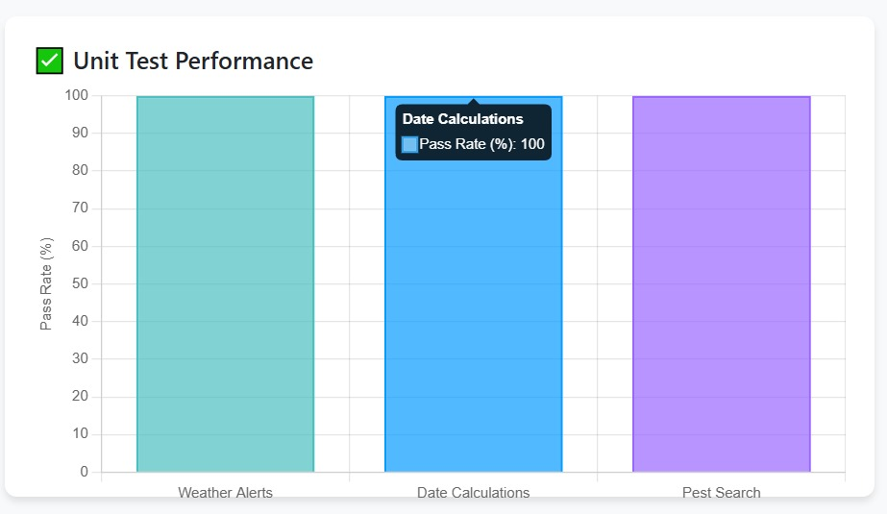

2. Unit Test Performance Bar Chart

Description:

This horizontal bar chart displays the test coverage and success rate across the application's three core modules: Weather Alerts, Date Calculations, and Pest Search. Each bar represents a module, with the length indicating the percentage of passed tests (out of 100%).

Purpose & Value:

* Quality Assurance: Demonstrates the reliability and robustness of each application component
* Performance Monitoring: Provides immediate visual feedback on system stability
* Development Tracking: Serves as a quality metric during continuous integration and deployment
* User Confidence: Shows end-users that the application has been rigorously tested and verified
* Technical Insight: The consistent 100% pass rate across all modules indicates comprehensive test coverage and successful validation of all critical functionality, ensuring dependable performance for agricultural decision-making.

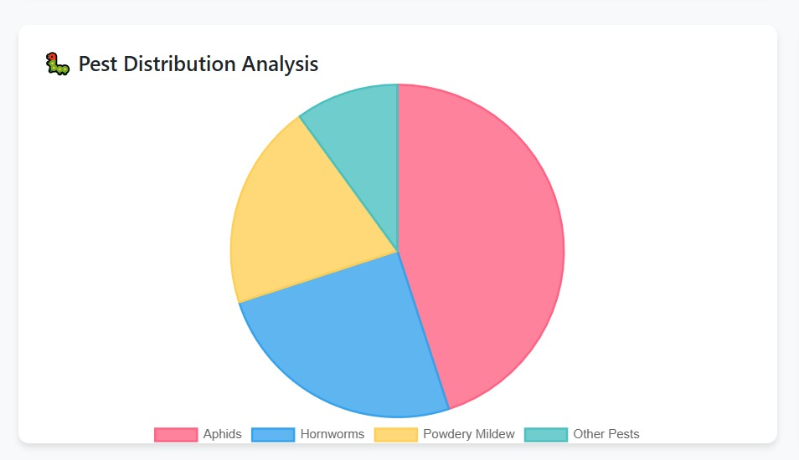

3. Pest Distribution Pie Chart

Description:

This pie chart illustrates the relative frequency of different pest types encountered in the agricultural database. Each colored segment represents a pest category, with the size proportional to its occurrence percentage. The chart uses a clear color scheme: red for Aphids, blue for Hornworms, yellow for Powdery Mildew, and teal for other pests.

Purpose & Value:

* Risk Prioritization: Helps farmers identify which pests require immediate attention and resources
* Prevention Planning: Guides the development of targeted pest management strategies
* Resource Allocation: Assists in determining the appropriate quantity and type of treatments needed
* Seasonal Awareness: Provides awareness of common pests during different growing seasons
* Technical Insight: The chart reveals that Aphids constitute nearly half (45%) of all pest occurrences, indicating they should be the primary focus of integrated pest management programs, followed by Hornworms (25%) and Powdery Mildew (20%).



## Limitation and Future Improvements

Limitations and Future Improvements

a) Current Limitations:

* Data Scope: The pest database is currently static and limited to a few common pests. A more comprehensive database is needed for wider applicability.
* Location Services: Weather functionality requires manual location input; automatic geolocation is not implemented.
* Offline Functionality: The app is fully dependent on an internet connection due to API calls and lack of client-side data caching.

b) Future Improvements:

* Advanced Data Integration: Integrate with soil moisture APIs and satellite imagery APIs for enhanced analytics.
* Predictive Analytics: Incorporate machine learning to predict pest outbreaks or yield estimates based on historical weather and planting data.
* Mobile Application: Develop a companion mobile app for Android and iOS to provide farmers with real-time alerts and reminders in the field.
* Expanded Database: Partner with agricultural universities to build a more extensive, scientifically validated pest and plant disease database.



## Prepared Defense Answers

Q: Why did you choose Python and Django?

A: "Python is renowned for its readability and rapid development capabilities, which was ideal for prototyping. Django was chosen for its 'batteries-included' philosophy—it provided built-in admin panels, authentication, and a robust ORM out-of-the-box, saving significant development time and ensuring a secure foundation."

Q: Your pest database is small. How would you scale it?

A: "You're absolutely right. The current database is a proof-of-concept. To scale, we would migrate from a simple list to a dedicated SQL database. We would structure it with related tables for pests, plants, solutions, and images. This relational model allows for efficient querying, easier management through a custom admin interface, and future expansion to thousands of entries without performance loss."

Q: How would you make your weather data more accurate for agriculture?

A: "Great question. General weather APIs are a start, but agricultural decision-making requires more specific data. The next step would be to integrate specialized ag-weather APIs that offer metrics like evapotranspiration rates, soil temperature at different depths, and leaf wetness duration, which are critical for irrigation and disease prediction."

Q: Who is the target user for this application?

A: "Our primary target users are small-scale organic farmers and serious home gardeners. They are often highly knowledgeable but lack the resources for expensive farm management software. This tool empowers them with integrated data to make better decisions, ultimately saving time, reducing crop loss, and increasing yield."

Q: What was the most challenging part of the project?

A: "The most challenging aspect was designing a testing strategy that was comprehensive yet manageable for a solo developer. Creating the automated test runner that bridges the gap between pytest's results and a human-readable Excel report for assessment was a complex but rewarding task that ensured full traceability of our testing process."



## Reference

* Olabanji, M.F., Ndarana, T. & Davis, N. (2021) *Impact of Climate Change on Crop Production and Potential Adaptive Measures in the Olifants Catchment, South Africa.* Department of Geography, Geo-informatics and Meteorology, University of Pretoria.
* Kephe, P.N., Ayisi, K.K. & Petja, B.M. (2021) *Challenges and Opportunities in Crop Simulation Modelling under Seasonal and Projected Climate Change Scenarios for Crop Production in South Africa.* Agricultural & Food Security, 10(10), pp. 1–14.
* FAO (2019) *Climate-Smart Agriculture Sourcebook.* Food and Agriculture Organization of the United Nations.